## **Vrinda Stores Annual Report – 2022**

**Project Title:** Sales Analysis of Vrinda Stores

**Prepared by:** Sangeeta Pondrati

**Tools Used:** Excel, Power Query Editor

## **Objective**

Vrinda Stores aimed to create an annual sales report for 2022 to understand their customers better and enhance sales strategies for the following year.

**About Dataset**

Index

Order ID -- unique identifier for each order.

Cust ID -- unique identifier for each customer.

Gender – Gender of the customer(Men or Women)

Age – Age of the customer.

Date – The Order date of the product.

Status – status of the orders(like Delivered, cancelled, refunded and returned)

Channel – Sales channel through which the order is being placed(Myntra, Ajio, Amazon, Flipkart,

Mesho, Nali)

SKU – stock keeping unit, it is the unique identifier for each product.

Category – Product category (Tops, Kurta, Western dress etc.)

Size – Size of the product.

Qty – Quantity of the product order at each order.

Currency – currency of the country( India-rupees).

Amount – Amount of money spent at each order.

Ship-city - City Name where the order has been delivered.

Ship-state – States Name where the order has been delivered

Ship-postal-code – Postal code of the state.

B2b – Business- to - business indicator, indicating by boolean values if the order is B2B transaction.

**Data cleaning**

* Check the dataset for null and blank values.
* Make sure data is consistent and clean with respect to data type, data format and values used.
* Standardizing gender value by replacing “M” as Men and "W" as Women in the gender column.
* Standardizing quantity value by replacing “One” as 1 and “Two” as 2 in the quantity column.

**Data processing**

* A new column “Age Group” was created to categorize customers based on their age using the IF formula.

**=IF(E2>= 60; "Senior"; IF(E2>= 30;"Adult"; "Young"))**

* Create new column- date- using text()

**=TEXT(G2,”mmm”)**

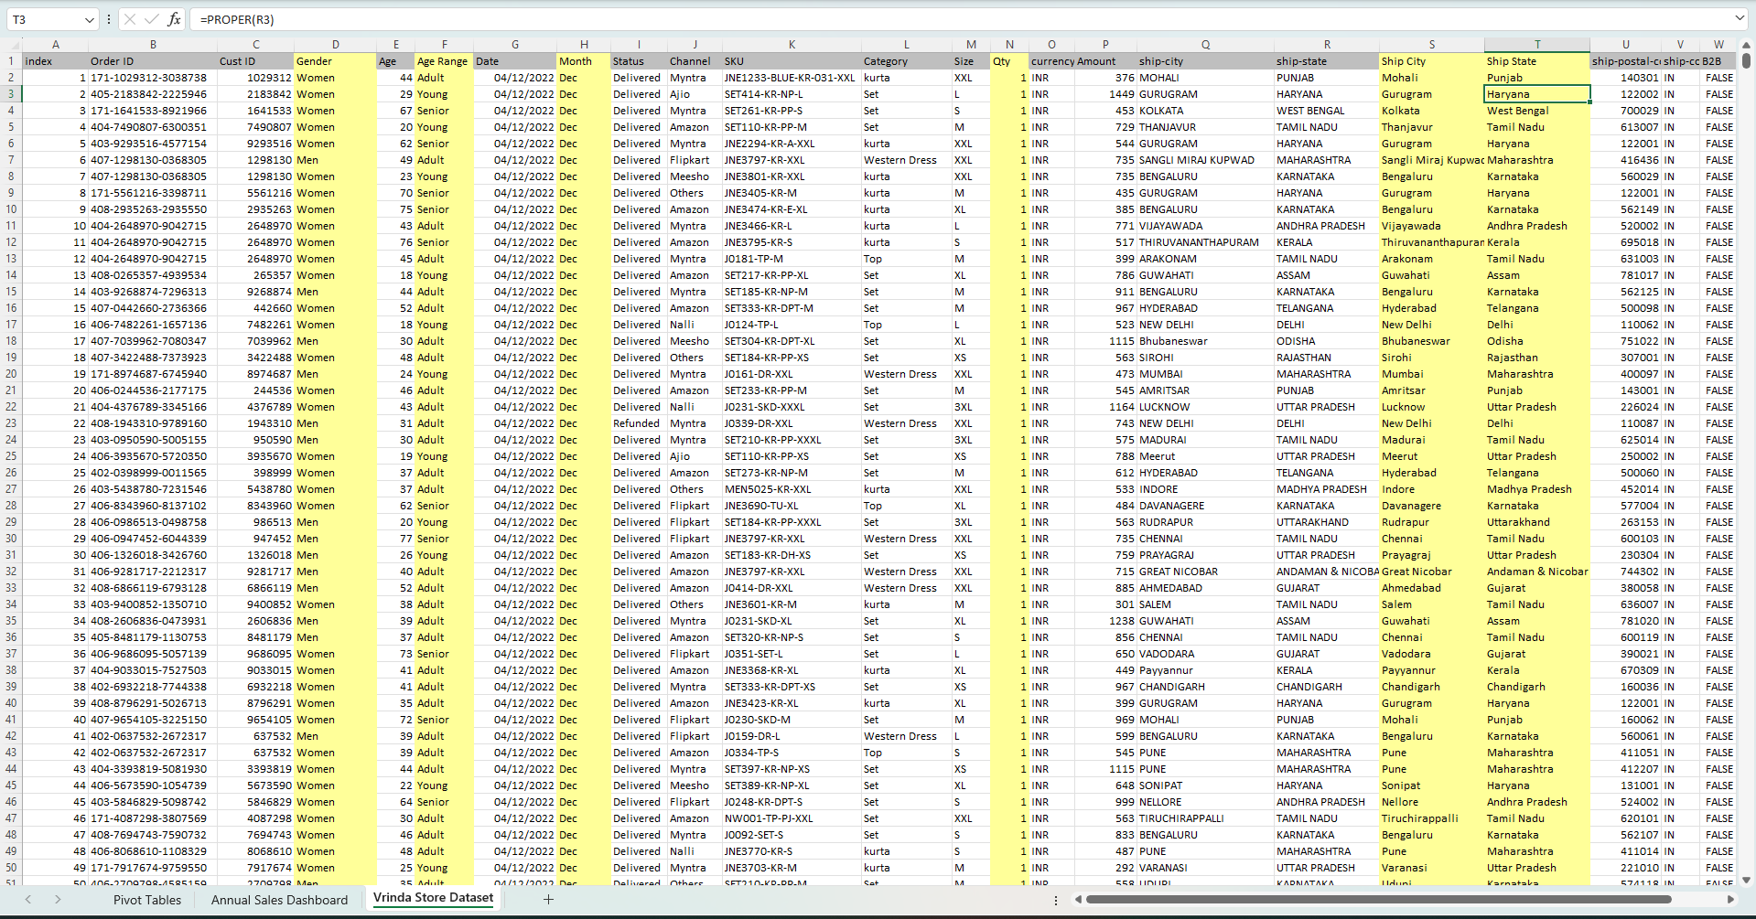

## 

## 

## 

## 

## **Overview of the project**

This Project involves analyzing ‘ Vrinda Stores' annual sales performance for 2022 using Excel. By visualizing sales data in an interactive and dynamic manner, the report offers valuable insights that aid in understanding sales trends, identifying top-performing products, and evaluating the effectiveness of sales strategies.

### **Key Metrics**

* The total Sales is ₹21,176,377.
* The total count of orders is 31,047.
* Average Order Value: ₹74.74
* The Most Sold Category is Set.

**Monthly Sales Trend**

Shows the monthly trend of the sales

* March witnessed the highest sales,followed by January and February.
* November and December show the lowest sales and order.

### **Customer Demographics**

### **By Gender:**

* Women made more purchases than men, with 64% of total sales coming from women and 36% from men.

**By Age Group:**

Adult women are the most active buyers

* Adults (26–45): Dominated with 39% (Women) and 17% (Men)
* Young (18–25): 21% (Women), 9% (Men)
* Senior (45+): 4% (Women), 9% (Men)

### **Order Fulfillment Status**

An order fulfillment rate of 93% demonstrates a high level of operational effectiveness and reliability.

* Delivered: 93%
* Refunded: 4%
* Returned: 2%
* Cancelled: 1%

**Regional Sales Performance**

*Maharashtra leads with a significant margin.*

Top 5 states by total sales:

* Maharashtra – ₹2,990,221
* Karnataka – ₹2,646,358
* Uttar Pradesh – ₹2,104,659
* Telangana – ₹1,714,239
* Tamil Nadu – ₹1,678,877

**Sales Channel Distribution**

*Amazon is the top-performing channel, followed closely by Myntra and Flipkart.*

* Amazon: 35%
* Myntra: 23%
* Flipkart: 22%
* Meesho: 5%
* Ajio: 6%
* Nalli: 5%
* Others: 4%

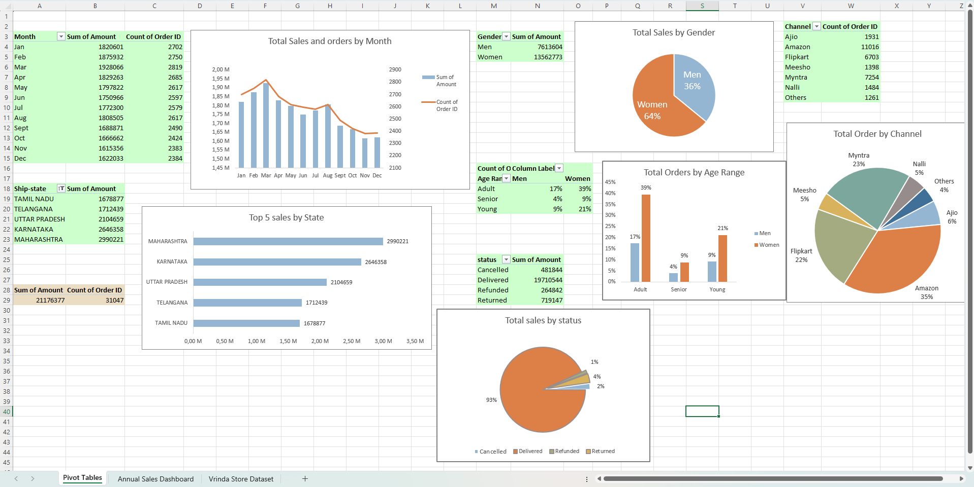

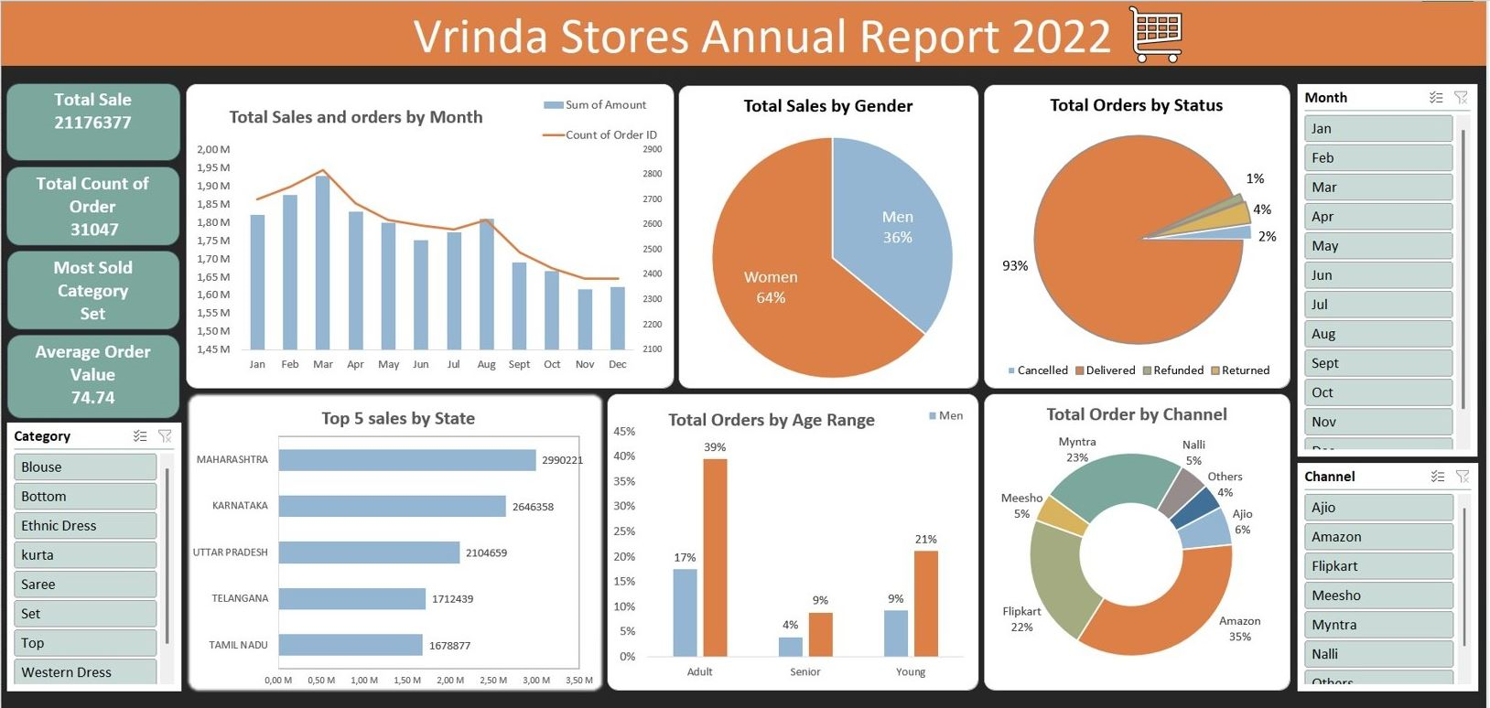

### 

### 

### **Recommendations**

### Based on the insights from Vrinda Store's 2022 sales data, here are some recommendations.

* Target adult women customers (aged 59-30) in Maharashtra, Karnataka, and Uttar Pradesh by running focused advertisements, offering attractive deals, and providing discount coupons on leading platforms such as Amazon, Myntra, and Flipkart.
* Focus product development and promotions on the “Set” category.

### **Conclusion**

The Vrinda Stores Annual Sales Analysis for 2022 offers useful insights into sales performance and customer behavior. The report highlights important trends, such as customer preferences, top-performing sales channels, and product categories. These insights can help the business make smarter decisions, improve sales strategies, and work more efficiently. Overall, this analysis provides a strong base for future planning and growth, supporting Vrinda Stores in making data-driven decisions for long-term success.